**NAME : SHENBAGAM C**

**REG.NO : N8MCAL039**

**SUBJECT : DATA ANALYTICS**

**ASSIGNMENT**

**DATA MAPPING:**

Data mapping is essentially a way to surface and prevent issues ahead of time, before they create bigger problems later. For example, two critical data sources may provide information in different formats. ... Any of those outcomes will have a negative impact during the data analysis phase

* Data mapping is a necessary component of the larger processes of [data migration](https://www.alooma.com/blog/what-is-data-migration) and [data integration](https://www.alooma.com/blog/what-is-data-integration). It’s a mechanism that matches fields from data sources (system A) to the target fields in a data warehouse or other storage repository (system B).

Challenges with data mapping:

Here are a few of the major challenges that can arise with data mapping:

* **Inaccuracy.** Any process undertaken by humans can turn into a liability since the potential for errors and misinformed decisions is so high. Inaccurate, duplicate, or otherwise decayed data has little use to the various teams in your organization as it can provide false insights that take the company further from its goals, not closer.
* **Time-wasting.** In-house teams already have enough responsibility on their plates. Tasking them with mapping data means time spent double-checking and re-working scripts and schemas to approach a high level of accuracy and certainty. And if fields are mapped incorrectly, it can result in significant data loss and even more re-work.
* **Changes.**Rarely can you "set it and forget it" with a data map. Changes can occur at any time — to standards, reporting requirements, software processes, and systems — which makes any prior data map obsolete.

**Evaluation Models:**

Researchers have developed models to guide trainers in conducting effective evaluations. Each of these four models has a somewhat different perspective, but there are also similarities. Click on a model below to review key learning points:

* [Stufflebeam's Context, Input, Process, Product (CIPP) Model](http://www.humtech.com/htoffice/website/sites/K606demo/K606EOT/KeyPoints/points2.htm" \l "item1)
* [Brinkerhoff's Six-Stage Model of Evaluation](http://www.humtech.com/htoffice/website/sites/K606demo/K606EOT/KeyPoints/points2.htm" \l "item2)
* [Bushnell's Systems Approach to Evaluation](http://www.humtech.com/htoffice/website/sites/K606demo/K606EOT/KeyPoints/points2.htm" \l "item3)
* [Kirkpatrick's Levels of Evaluation Model](http://www.humtech.com/htoffice/website/sites/K606demo/K606EOT/KeyPoints/points2.htm" \l "item4)

**Stufflebeam's Context, Input, Process, Product (CIPP)** model is one evaluation model that is used for evaluating management training. It involves four types of evaluation and has some connections to the Instructional Systems Design model. The CIPP model emphasizes collecting information from a variety of sources to provide data for making better decisions.

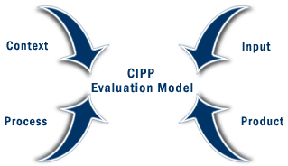

**Brinkerhoff's Six-Stage Model of Evaluation** is based on the Instructional Systems Design training cycle and follows a circular pattern. It stresses the importance of continuous evaluation and the need to change a course of action if the proposed approach is not working.

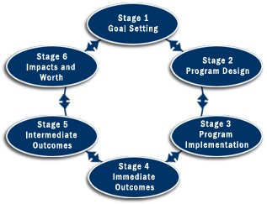

**Bushnell's Systems Approach to Evaluation** is based on the idea that the outcome will be only as good as what goes into the process. It emphasizes that evaluation measurement should occur between each of the stages and between the four stages in the process stage to ensure that the program is well designed and meets its objectives.

http://www.humtech.com/htoffice/website/sites/K606demo/K606EOT/Lessons/images/U2-3.gif

Donald Kirkpatrick developed one of the most commonly used models for evaluating training.**Kirkpatrick's model** is a four-level model of training evaluation that allows the measurement of different training outcomes including participant reactions, learning, on-the-job behavior, and organizational results.

|  |
| --- |
| [http://www.humtech.com/htoffice/website/sites/K606demo/K606EOT/Lessons/images/U2-4_01.gif](http://www.humtech.com/htoffice/website/sites/K606demo/K606EOT/KeyPoints/points2.htm) |
| [http://www.humtech.com/htoffice/website/sites/K606demo/K606EOT/Lessons/images/U2-4_02.gif](http://www.humtech.com/htoffice/website/sites/K606demo/K606EOT/KeyPoints/points2.htm) |
| [http://www.humtech.com/htoffice/website/sites/K606demo/K606EOT/Lessons/images/U2-4_03.gif](http://www.humtech.com/htoffice/website/sites/K606demo/K606EOT/KeyPoints/points2.htm) |
| [http://www.humtech.com/htoffice/website/sites/K606demo/K606EOT/Lessons/images/U2-4_04.gif](http://www.humtech.com/htoffice/website/sites/K606demo/K606EOT/KeyPoints/points2.htm) |

**VALIDATING MODEL:**

**Model validation** is defined within regulatory guidance as “the set of processes and activities intended to verify that **models** are performing as expected, in line with their design objectives, and business uses.” It also identifies “potential limitations and assumptions, and assesses their possible impact.”

**The Four** Elements:

Model validation consists of four crucial elements which should be considered:

[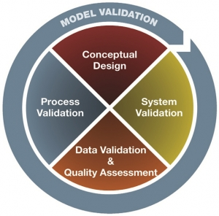](https://www.bba.org.uk/wp-content/uploads/2016/01/thefourelements.jpg)

**1.Conceptual Design**

The foundation of any model validation is its conceptual design, which needs documented coverage assessment that supports the model’s ability to meet business and regulatory needs and the unique risks facing a bank.

**2.System Validation**

All technology and automated systems implemented to support models have limitations. An effective validation includes: firstly, evaluating the processes used to integrate the model’s conceptual design and functionality into the organisation’s business setting; and, secondly, examining the processes implemented to execute the model’s overall design.

**3.Data Validation and Quality Assessment**

Data errors or irregularities impair results and might lead to an organisation’s failure to identify and respond to risks. Best practise indicates that institutions should apply a risk-based data validation, which enables the reviewer to consider risks unique to the organisation and the model.

**4.Process Validation**

To verify that a model is operating effectively, it is important to prove that the established processes for the model’s ongoing administration, including governance policies and procedures, support the model’s sustainability. A review of the processes also determines whether the models are producing output that is accurate, managed effectively, and subject to the appropriate controls.

***THANK YOU !!!!….***